**Buskirk-Chumley Theater**

**Technical Form**

**RETURN AT LEAST 3 WEEKS PRIOR TO YOUR EVENT**Please return this form (as a Word doc, if possible) to:

**Director of Operations**

Jordan Ferguson

events@buskirkchumley.org

812.323.3020 ext 2

**Additional Contacts**

**Tech Director Assistant Tech Director Events Coordinator**David DeSante Clayton Hicks Ahmed al-Awadi tech@buskirkchumley.org atech@buskirkchumley.org aawadi@buskirkchumley.org

# EVENT INFORMATION

|  |  |
| --- | --- |
| Event Name | TEDxIndianaUniversity Tipping Point |
| Event Date(s) | 21 Feb 2025, 6 p.m. |
|  |  |
| Day-of-show Contact Name* | *President name* |
| Day-of-show Contact Phone | *President number* |
| Day-of-show Contact Email | *President email* |
|  |  |
| Technical Contact Name, if applicable** | *TP Director name* |
| Technical Contact Phone | *TP Director number* |
| Technical Contact Email | *TP Director email* |

**\*** This person will be on site on the day of the event, should have authority to make decisions, and be available to the House Manager and/or Events Director.  
** Additional person, if available, who can answer questions about audio needs, cues, and lights, such as the stage manager or tour manager.

# LOBBY SETUP

## Lobby Terminology:

Outer lobby – the large tiled area closest to the sidewalk/Kirkwood Avenue where concessions windows are located  
Inner lobby – the wide carpeted area that patrons enter after their tickets have been torn  
Mezzanine – the wide area that overlooks the Inner lobby with the sloped ceiling

## Tables

The Theater has twenty six-foot rectangular tables and twenty maroon tablecloths/skirting available at no charge. We also have two cocktail tables. Any other tables or linens should be provided by an outside vendor. If you are having catering, we recommend setting up their station in the West Hallway with 1-2 tables for prep. This space is not accessible to the public. If you plan on having programs, we recommend a table in the inner lobby.

*We anticipate we’ll need BCT table covers for all the tables*

|  |  |  |  |  |
| --- | --- | --- | --- | --- |
|  | Outer Lobby  (2 max) | Inner Lobby  (2 max) | Mezzanine  (4 max) | West Hallway  (2 max) |
| How many tables? | 2 | 2 | 4 |  |
| To be used for? | Tickets/photos/etc | Activities | Activities |  |

### More table info

## Merchandise

Do you have **merchandise** (your CDs, t-shirts, books, etc.) to sell in the lobby? **yes no**

We can provide secure wi-fi but **cannot** provide devices or software for processing credit card sales. We can provide a cash box to hold your change. Let us know if this is a need! Don’t forget to bring signage with your prices! The Buskirk-Chumley Theater does not take any percentage of an artists or organizations merch sales.

Merch will be sold (check all that apply):

Before show (should be set up 1 hour prior to show time)

During intermission, if applicable

After the show

What do you plan to sell?

|  |
| --- |
| T-Shirts |

Would you like a qualified Buskirk-Chumley Theater staff member to sell you merchandise for you? **yes no**

**We charge a $150 fee for providing you with a merch seller.** This person will be qualified to count in, count out, and sell your merchandise through cash and/or web sales throughout the duration of your event.

If not a BCT staff member, who will be responsible for selling your merch?

|  |
| --- |
|  |

## Other Lobby Logistics

Will you have **programs**, flyers, or other materials for our ushers to distribute to patrons? **yes no** (we will also have volunteers to help with playbill/pamphlet distribution)

Please make sure programs are delivered two hours prior to showtime. If so, we recommend to have a table in the inner lobby.

Will you have **banners or other displays** to hang or set on the floor**? yes no**

Do you need the BCT’s **pipe and drape system** set up for a photo booth? **yes no**

**We charge a $25 fee to setup the pipe and drape.**

(Due to the limited space in the lobby, we only recommend using the pipe and drape when you will be actively encouraging photos for some particular reason and you don’t have competing lobby activities.)

Our pipe and drape backdrop is maroon cloth. Would you like to provide **your own backdrop**? **yes no**

### Where would you like it set up?

|  |
| --- |
| n/a |

### More lobby info

*All items affiliated with your rental must be removed from the theater at the conclusion of your event(s), unless prior arrangements have been made with the Director of Operations.*

## Concessions

Buskirk-Chumley Theater will sell concessions in the fashion determined by the renter in the Wedding Planning Form. Lessee may not sell or distribute any alcoholic beverage at the Buskirk-Chumley Theater. Food items made available for distribution or sale must be provided by a licensed restaurant/caterer and are subject to a catering/cleaning fee. Please talk through your ideas/needs for bar/concessions with the Director of Operations to make sure we are in accordance with Indiana liquor laws. We can also brainstorm drink specials for your special day. **Concessions currently only accepts card payments.**

## Photo Policy

The BCT’s default house policy is to allow photos without flash only for the first three songs (or the first 10 minutes, if not a concert) of each act. An announcement will be made about your selected policy prior to the show.

**Preferred photo policy: no photos BCT House Policy photos w/o flash and videos encouraged throughout**

# EVENT OVERVIEW

## Event Summary

Please provide a brief summary of the different elements of your event. Will there be speakers? A band? Singers? Video? Slide presentation?

|  |
| --- |
| 6 speakers  1 band for intermission (received confirmation from band… will send technical needs asap)  Video and slides using the large projector and the 16’x9’ projection screen |

## Event Schedule

Please outline, in as much detail as possible, your schedule for the day and the event. Please refer to the example as a guide for what items to include. If you have a detailed script of your own, feel free to attach it with this form. Doors are 30 minutes prior to event start unless indicated differently on the publicity form.

|  |  |
| --- | --- |
| **9:30 AM**   * TEDx Production starts setting up stage and figuring out tech   **12:00 PM**   * TEDx Production members break for 30 min “union” break   **1:15 – 3:30 PM**   * Coffee beanery delivery (coffee + donuts) * Dress rehearsal * Production, Curation, Operations, Engagement, President and Speakers will be present   **3:00 PM**   * Engagement & Membership will setup tables in outer lobby, inner lobby, and mezzanine   **3:30 PM**   * TEDx Production members break for 1 hr “union” break   **4:15 PM**   * Remaining TEDx Members will arrive at BCT   **4:30 PM**   * TEDx member photos with photographer   **5:30 PM**   * Doors Open to general public   **6:00 PM**   * Show begins   **8:15 PM**   * Audience post-talk debrief time in lobby   **8:30 PM**   * Audience files out; TEDx folks have dinner   **9:00 PM**   * TEDx folks clean Up BCT   **9:30 PM**   * End | **EXAMPLE EVENT SCHEDULE**  *Pre-Event*  1pm – custom backdrop delivered  3pm – day-of-show contact arrives  5:30 – catering delivered  6pm – merch seller arrives  6pm – tour manager arrives  6:30-7:30 – VIP reception  *Event*  7:30 - doors open (usually 30 minutes prior to event)  8pm – Introduction by Director  8:05pm – First half begins, introduced by MC   1. Group 1 act, CD track 1 2. MC announces next act 3. Soloist, CD track 2, spotlight   9pm – Intermission begins  9:15pm – Second half begins, introduced by MC   1. Group 2 act, CD track 9, smoke machine during performance   9:50pm – Whole group onstage for finale  9:55pm – Farewell and thank you from Director  10pm – event ends  *Post-Event*  10:15pm – musicians signing CDs in outer lobby  10:15pm – load out of stage equipment  10:45pm – exit building |

*Please denote a time of arrival or load-in time for each day so that our staff know when to be present. Remember that you can only gain access to the theater when a staff member is present.*

## Parking

If you have parking needs *(such as needing to park and load in/out from buses, trailers, multiple vehicles, etc.)* we can accommodate this by reserving parking spots in the 4th & Washington lot behind the theater for a $20 overall fee.

Would you like us to **reserve parking spaces** for you? **yes no**

If **yes**, how many would you like reserved, where, and for what type of vehicle(s)?

|  |
| --- |
| *8-10 would be nice, but if you can’t reserve that many, let us know!* |

# STAGE EQUIPMENT

Most stage equipment is included in your rental fee. Check your contract for details on additional fees.

**Artist Rider and Stage Plot**

**Please send via email to events@buskirkchumley.org and tech@buskirkchumley.org.**

If your event is a benefit concert or involves a technical contact that is not the contracting entity, please list their email and phone number below.

|  |
| --- |
|  |

*You can also drag and drop to build a stag plot on page 8.*

## Stage Setup

## Please answer the questions below and locate the necessary items on the Stage Plot later in the form.

*See stage plot later in the form for full staging information*

Will you use the **piano**? Additional fees apply. **yes no**

If so, provide location of piano: ___________________________________

Will you use the **podium and mic? yes no**

If so, preferred location on stage for podium (**SEE DIAGRAM Pg. 6**): stage right center stage left

Will you require the **stage extension** to expand the stage into the orchestra pit? **yes no**

If so, additional fees apply and seating capacity will be reduced. Indicate which size extension is needed: 6’ 10’

Will you need **tables on stage? yes no**

If so, how many and where should they be placed: _____________________________________

Will you need **tables in the orchestra pit? yes no**

If so, how many and where should they be placed: ___________________________________

*Please note that a total of twenty six-foot tables and twenty tablecloths are available for the lobby and on the stage.*

Will you need **chairs on stage? yes no**

If so, how many and where should they be placed: ___________________________________________

What **on-stage backdrop** do you prefer? **brick wall Cyc (white curtain) black curtain other:**

Will you use the Indiana Dogbone Neon Sign? **yes no**

*See page 11.*

Will you need to open or close the **curtain** during the show? **yes no**

If so, provide detailed instructions: ________________________________________________

Unless otherwise instructed, the curtain will remain open during the entire event.

### More stage setup info

## Audio

Will you need **wireless** **handheld mics** for speakers making brief remarks or moving around the stage? **yes no**

(Note: TOTAL of 2 Wireless Channels; Handheld OR Body Mics.) If so, how many: *2 handheld mics*

Will you need **wireless** **body mics** for speakers who will move around the stage and cannot hold a mic? **yes no**

(Note: TOTAL of 2 Wireless Channels; Handheld OR Body Mics.) If so, how many: *4 body mics*

Will you need **wired mics and mic stands** for instruments, singers, or stationary speakers? **yes no**

(Note: Wired Mics CANNOT move.) If so, how many: *Possibly 1 for the band, TBD*

Will you need **audio monitors** (usually for musicians who need to hear their performance)? **yes no**

If so, how many: *Yes, for band*

Would you like to use our **vintage mic** for vocals or any other part of your event? **yes no**

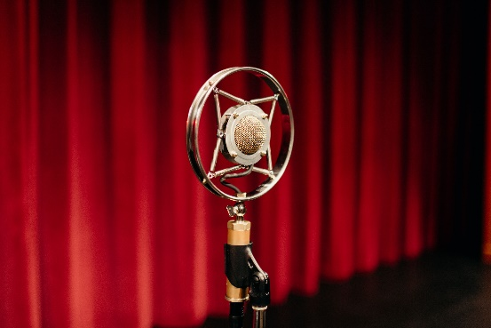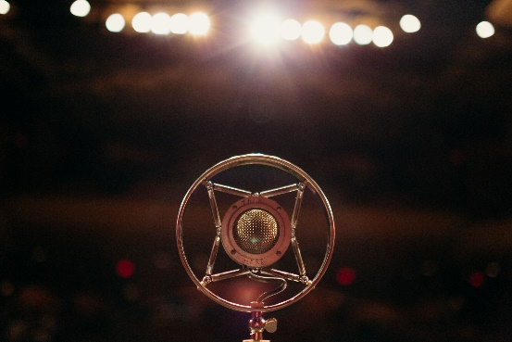

Do you have specific **music** you’d like played before the event, as the audience arrives? **yes no**

Would you like to use the theater’s Spotify for preshow music? **yes no**

If yes, please email a link to the playlist (be sure it’s a public playlist) or let us know what kind of music you prefer and we can find a playlist for you: ____________________________________________

If not, what will be the source of music: laptop CD flash drive other:

Will the technician need to play **music/sound effects/recorded announcements** during your event? **yes no**

If so, what will be the source of music: laptop CD flash drive other:

*We will have TEDx members/volunteers aiding with running music/sound effects/pre-recorded video/live stream. Realistically, the only thing that we’d leave to BCT technical staff would be lighting and live audio mixing.*

### More audio info

## Lighting

Will you need a *moving spotlight* to follow performers around on the stage? **yes no**

You can provide staff to operate the spotlight or we can hire an operator for you at an additional fee.

If you have complicated lighting effect requests, please contact the Technical Director at tech@buskirkchumley.org to schedule an appointment to discuss your needs. If you have simple requests (purple lights on the backdrop throughout the show, disco ball lit for the final number, etc.), please describe them here. We’ll contact you if we need more information.

|  |
| --- |
| *Since we release video recordings of our TEDx Talks, we’d like a three-point lighting scheme. Additionally, it would be nice if the TEDx sign was illuminated with low intensity by an additional front light.* |

### More lighting info

## Projector/ Screen

Will you need to **project film, slides, or images** during the event? **yes no**

We have two screen sizes. The 16’ x 9’ screen is best used behind a speaker or performer. The 28’ x 20’ screen fills the entire proscenium and is most often used for film screenings.

Screen required: 16’ x 9’ 28’ x 20’

*We’ll use the smaller screen but use the larger projector.*

Source of projection: laptop DVD Blu-Ray DCP (digital cinema package) flash drive other:

The minimum charge for usage of the projector is $150 per day. *(You can have multiple screenings per day, but a rehearsal day and a performance day would be counted as two days.)* **If you plan to have a video or film component to your event, please get this to your technician 1-2 days before your event for testing.**

Will you need **video monitors** (usually for speakers to see the slides being projected behind them)? **yes no**

If so, how many: 2

### More projector/screen info

## Additional Equipment

Will you be bringing additional equipment (such as a keyboard, amps, fog machine, furniture, set pieces, etc.)? Please provide details here:

|  |
| --- |
| *We will bring a number of smaller videography components for A/V needs, a red TEDx carpet, aforementioned set pieces, and other various items* |

Do you need additional equipment not mentioned on this form? Additional fees may apply. Please provide details here:

|  |
| --- |
| *Mic harnesses or mic straps for people who might have ill-fit clothes for wireless packs*  *D'San Speaker Timer (Markeys)*  *Decimator for confidence monitors (Markeys)*  *BCT Logitech Long-Distance Clicker*  *BCT ATEM Switcher*  *BCT Cameras, connected to ATEM*  *BCT Ethernet connection (if possible, for stable video delivery)*  *BCT Large Projector (not small), flown stage left* |

Are there any other stage or technical elements we should be aware of that weren’t already mentioned in this form?

|  |
| --- |
| *Instrumentalists from Bloomington Delta Music Company will be performing during intermission. They will bring their own instruments. These instruments can be covered with velveteen-like cloth and stored up stage left (upstage of the projection screen) when talks are occurring.*  *Stage designs are provided in a previous section.* |

# TECHNICAL EXPENSES

At least one BCT technician must be present at all times. One tech can run sound and lights for a simple show but events involving extensive internal light and sound cues will require two technicians. The number of technicians needed will be determined by the Technical Director, based on the information provided on this form. **The minimum charge for technical labor is $300. This basic estimate includes 1 technician for 5hrs of time (including set-up and tear-down).** Your contract includes a quote for technical expenses, based on the information provided at the time. If you would like an updated quote based on revised plans, please complete this form with as much detail as possible and send it to events@buskirkchumley.org. Please see your contract for more information about additional equipment fees.

**DAY-OF INFO**

**Parking + Arrival**

While planning it is important to think about vendor parking needs as well. There are two loading spots located on Kirkwood Avenue in front of the theater that can be utilized for loading/unloading needs if available, but not for parking. Reserved parking will be indicated by orange “do not park” signs the City of Bloomington Parking Department puts up. If someone is parked in a spot that is not with your event, please let the Director of Operations know as soon as possible so actions can happen to remedy the situation. Theater staff will also occasionally put out cones to deter others from parking in reserved spaces. If these are out please remove them, put them to the side, and park in one of your spots! Patrons can find downtown parking info [here](https://www.visitbloomington.com/make-a-plan/maps-and-transportation/downtown-parking/).

All artists, presenters, performers, etc. should utilize the South entrance door upon arrival. Please do not enter through the Box Office or front lobby doors.

You technician will have the South entrance unlocked for you based on the time of arrival/building access you indicate on your day-of show schedule on this form.

**Aisles + Auditorium**

If your event involves many performers (dance, theater, etc.) please make sure to keep all aisles clear of things and at least a 3-foot clearance in the South hallway for emergency evacuations. All bag handles and straps should be tucked away to prevent tripping hazards. If your event involves helpers during the rehearsal or load in, they must all be out of the auditorium at least 30 minutes before doors open to the public. They are welcome to wait in the inner lobby to have their ticket scanned.

If you need special reserved seating signs in the auditorium, please let us know! We can put these out in the requested seats and you can let your guests know ahead of the show.

**Guest List/Comps**

The sooner you can get this to us the better. We want to provide a stress-free experience for your guests!

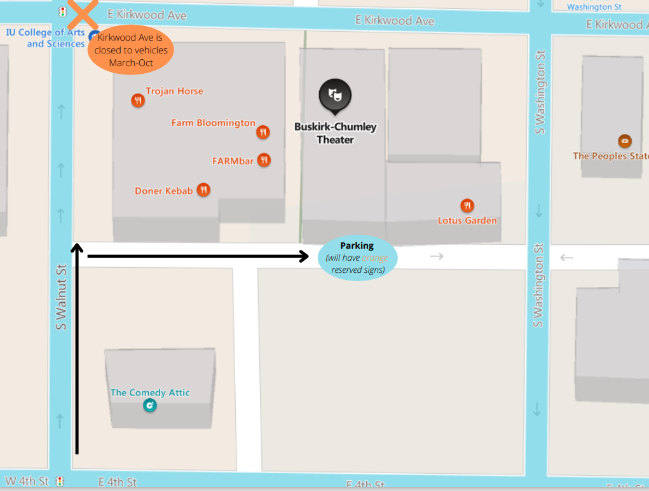

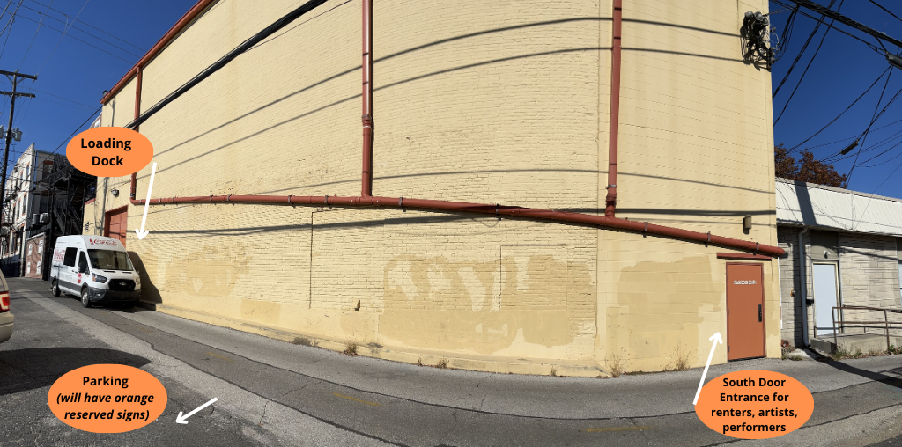

## Stage Plot Information – Draw Us A Picture!

TEDx Sign

Soft Goods

Pipe 13

Screen

Pipe 11

Tables – 6’x2.5’

Tables – 28”x24”

Tables – 4’x2’

Please label here:

Other:

Podium

Monitors

Mic Stands

Piano

Stools

Chairs

**Lobby Layout**

Please use the following diagrams to show us how you would like the lobby set up, including any items you will be bringing. 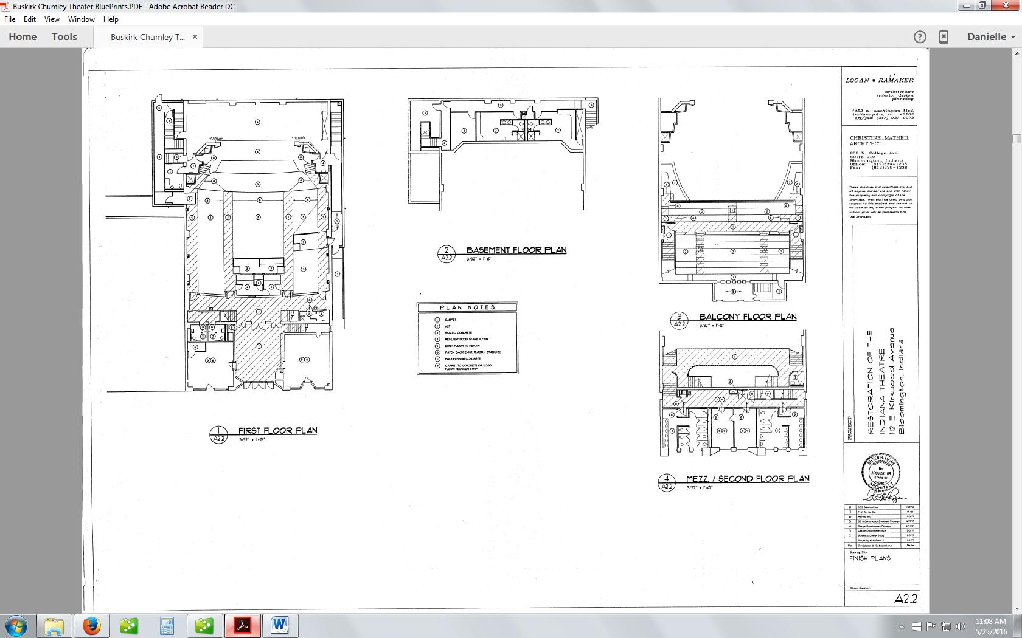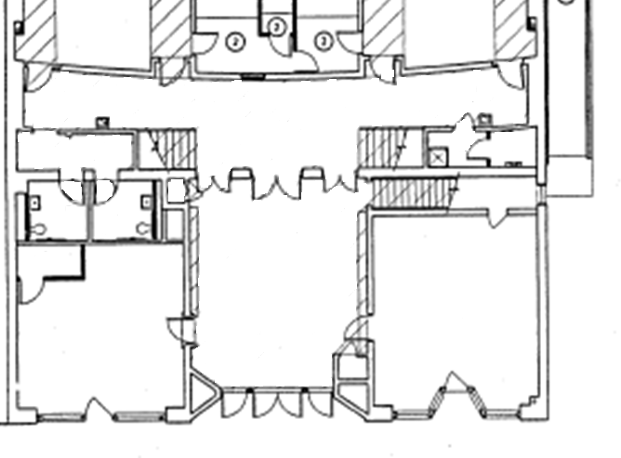

Tables – 6’x2.5’

**Concessions**

**Mezzanine**

**Inner lobby**

**BluBoy Cafe**

**Outer lobby**

**BCT Box Office**

Cocktail Tables

(please specify)

Other

Banner

Chairs

**You’re all done! Please refer to the additional information below or contact the Director of Operations at events@buskirkchumley.org if you need more technical guidance.**

## BCT Technician Notes:

|  |
| --- |
|  |

# ADDITIONAL TECHNICAL INFORMATION

# Lobby Information

## Tables

Tables in the outer lobby will be placed on the wall opposite the concessions windows, between the Blu Boy Cafe entrance and the stairs to the second floor. These are the default tables for merchandise sales. If you have programs to distribute to patrons, we generally set up one table in the inner lobby to hold those.

## Other Lobby Logistics

**Lobby Displays:** Please bring your own easel, tabletop or floor, to display your lobby items. We cannot use tape on painted areas of the building to display items. Items can be suspended from the inner lobby railing or from the lighting sconces or pilasters in the outer lobby. This works best when items are rigid or are hung on a rigid frame.

**Pipe and Drape:** This is a frame made up of two vertical pipes on bases and one horizontal pipe between them, suspending a drape, often used as a photo booth. We have a maroon drape that we can provide, but you are welcome to bring your own backdrop to attach to the pipe.

# Stage Equipment

## Stage Setup

**Backdrop options:**

**Cyc:** A cyclorama is a large piece of cloth that can be used as a backdrop. When lit, it appears solid and can create beautiful and virtually endless lightscapes.

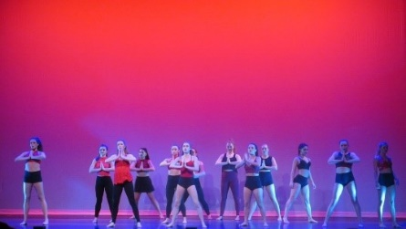 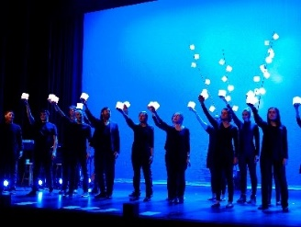

**Black Curtain:** This can also be lit to be any color or combination of colors.

## Z:\Marketing\Photos\Events\2017\082617 Moore & Sorg Wedding\082617 Moore & Sorg Wedding - photo credit Hilary Webb & Ryan Burton (15).jpgZ:\Marketing\Photos\Events\2017\041217 Marc Cohn\041217 marc cohn 1.JPG

**Brick:** The exposed brick of the back wall of the theater creates an interesting backdrop and can be lit in virtually endless ways.

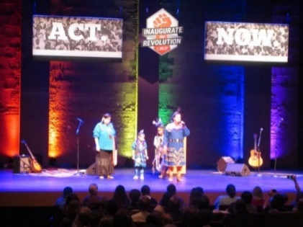 

**Indiana Dogbone Neon Sign:**

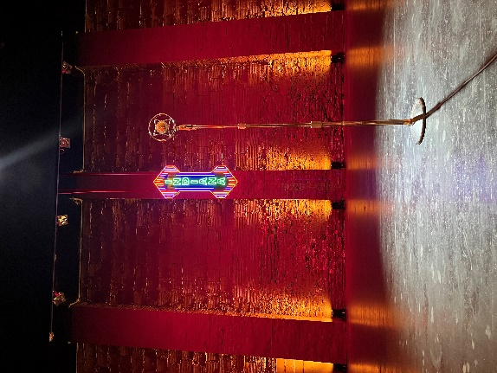

## Audio

The theater has two wireless mic & battery packs that can be set-up as headset, hand-held, or lapel mics. Numerous vocal and instrument mics are available and we have mic stands for 12 speakers/performers plus various mic stands for other uses. Providing details about your on-stage activities on this form will be enough for our technical staff to prepare the appropriate audio equipment. Technical details about our lighting, audio, and video equipment are available at buskirkchumley.org/rent-the-bct/.The theater has a separate comm system for communication from the tech booth to backstage and downstairs. This is built into the building and always available. Audio monitors are speakers, usually on-stage, that allow the performer to hear what the audience is hearing. Seven audio monitors are available

## Lighting

Follow-spots require the theater to hire spot operators, which will incur additional technical labor costs. Costs vary by the day of the week, length of show, and whether or not the spot ops are required to attend any rehearsals. You will be able to obtain a better estimate of the cost of spot operators for your event once the Technical Director has received this form. Up to two follow-spots are available. The disco ball is available upon request!

## Projector/Screen

The 16’x9’ screen hangs in the center of the stage, with 10 feet between the bottom of the screen and the stage floor. This screen is best for presentations.

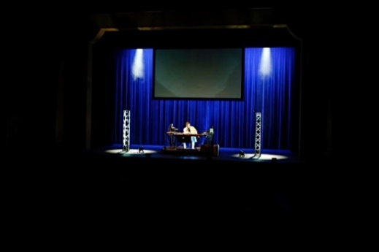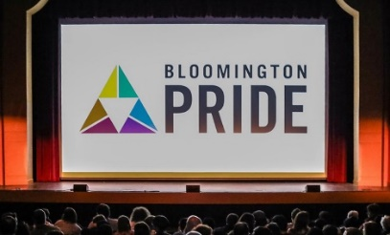The 28’x20’ screen fills the stage. This option is most often used for film screenings but it is versatile.